**IEEE Practice Xtreme Practice**

September 13th, 2019

**INTERVIEW WARMUP QUESTIONS**

01:

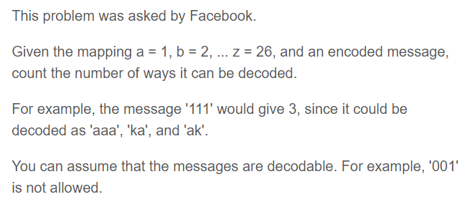

02:

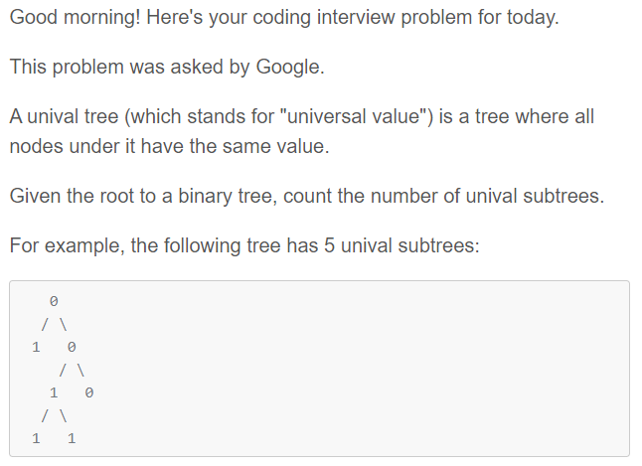

**PAST CODE JAM QUESTIONS**

03:

<https://codingcompetitions.withgoogle.com/codejam/round/00000000000000cb/0000000000007966>

04:

<https://codingcompetitions.withgoogle.com/codejam/round/00000000000000cb/00000000000079cb>

q